 | Monday | Tuesday | Wednesday | Thursday
Hoots Camp  5 to 7 years  Must be enrolled in Camp through KC | 9:35am – 10:05am | x | 9:35am – 10:05am | 9:35am – 10:05am
Bears Camp  8 to 9 years  Must be enrolled in camp through KC | 9:35am – 10:05am | 9:35am – 10:05am | x | 9:35am – 10:05am
Rainbow Fish Camp  @Community Center  3 to 6 years  Must be enrolled in camp through KC | 9:45am – 10:15am | 9:45am – 10:15am | 9:45am – 10:15am | x
Parent-Tot  12 to 36 months  30 Minutes, 5:1 ratio | 10:10 am - 10:40 am | 10:10 am - 10:40 am | 10:10 am - 10:40 am | 10:10 am - 10:40 am
Beginner 1  3 years and older  30 Minutes, 4:1 Ratio | 10:10 am - 10:40 am | 10:10 am - 10:40 am | 10:10 am - 10:40 am | 10:10 am - 10:40 am
Beginner 2  3 years and older  30 Minutes, 4:1 Ratio | 10:45am - 11:15am | 10:45am - 11:15am | 10:45am - 11:15am | 10:45am - 11:15am
Beginner 3  5 years an older  30 Minutes, 5:1 Ratio | 10:45am - 11:15am | 10:45am - 11:15am | 10:45am - 11:15am | 10:45am - 11:15am
Intermediate 1/2  5 years and older  30 Minutes, 5:1 Ratio | 11:20 am to 11:50am | 11:20 am to 11:50am | 11:20 am to 11:50am | 11:20 am to 11:50am
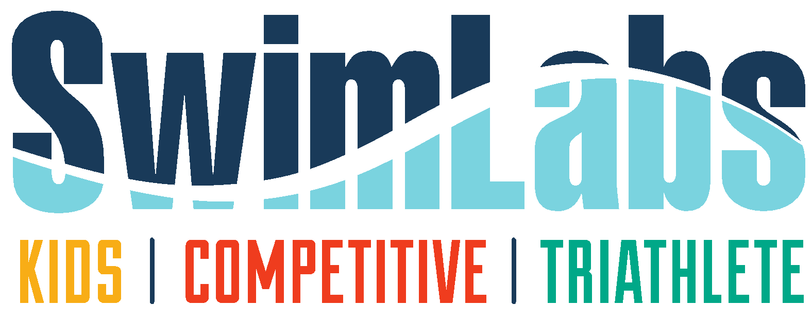
June Sessions | July Session | August Sessions
WEEK 1-June 3rd to 6th  WEEK 2- June 10th to 13th  WEEK 3- June 17th to 20th *  WEEK 4 -June 24th to 27th  WEEK 5 – No lessons 4th of July | WEEK 6- July 8th to 11th  WEEK 7- July 15th to 18th  WEEK 8- July 22nd to July 25th  WEEK 9- July 29th to August 1st | WEEK 10 -August 5th to 8th **  **NO Camp swim lessons offered week 10  *Bears camp week of 6/17: swim lessons will be on Monday/Tuesday/Wednesday due to a field trip on Thursday 6/20

